**RecordQA_PDFFunction  
03/11/2020 15:12:15**  
User Is Navigated To Site : http://172.19.9.53/ICRARevamp/#/login  
  
*****RecordQA_PDFFunction is Started *****  
Username is entered  
  
Password is entered  
  
Submit button is clicked  
Text of the element : Successfully logged in  
Successfully logged in  
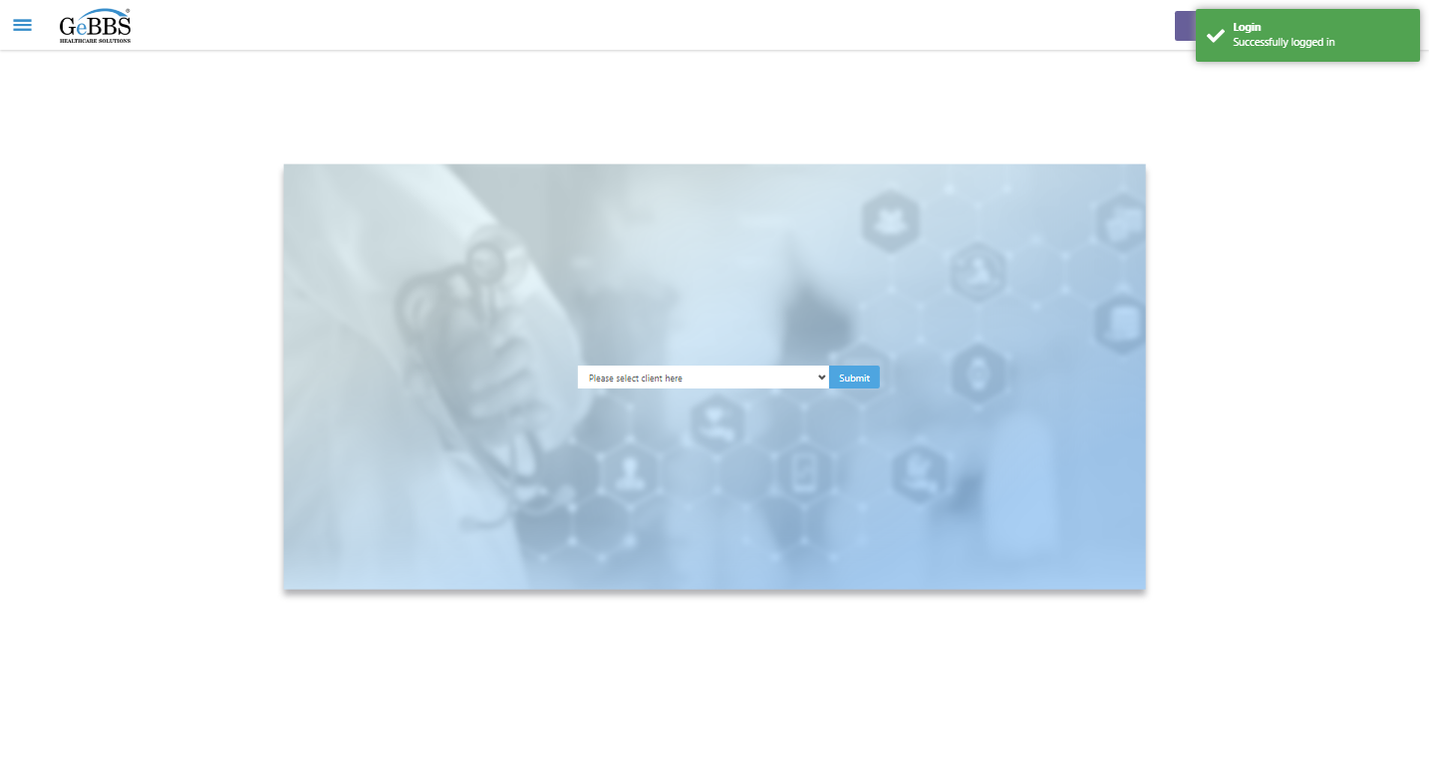  
Client dropdown button is clicked  
Client dropdown button is clicked  
Submit button is clicked  
Main Page loaded  
  
Scrolled successfully  
Chart Retrieval is clicked  
All submenus  
  
Submenu in 1 is :Field Tech  
Submenu in 2 is :FieldTech Area Assignment  
Submenu in 3 is :Intake  
Submenu in 4 is :RecordQA  
Submenu in 5 is :RecordQA Approval  
Scrolled successfully  
RecordQA is clicked  
RecordQA selected  
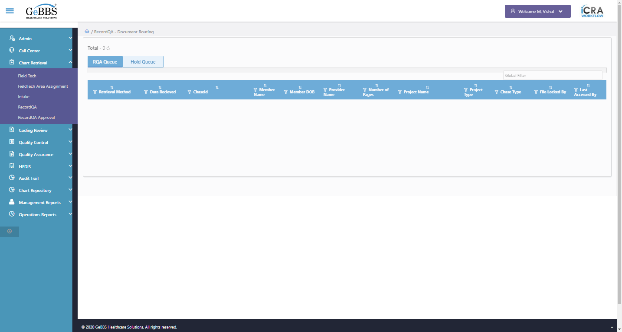  
Scrolled successfully  
Scrolled successfully  
Scrolled successfully  
Scrolled successfully  
Scrolled successfully  
Scrolled successfully  
Scrolled successfully  
Scrolled successfully  
Text of the element : 116472  
GolbalFilter is entered  
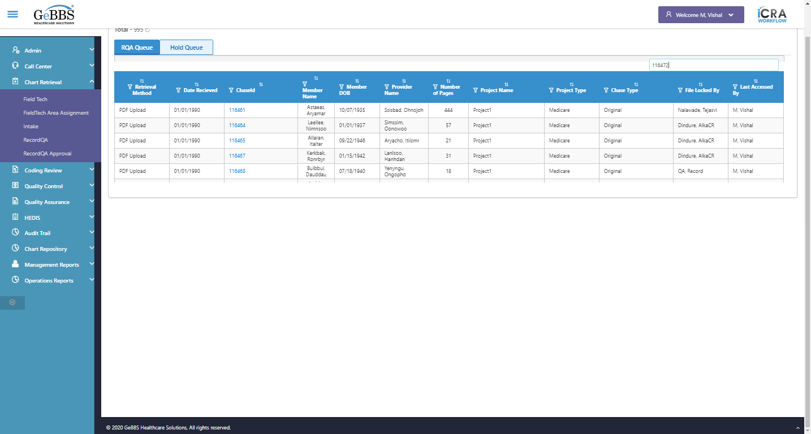  
Text of the element : 73  
chaseid is clicked  
frame is selected found and switched to   
Scrolled successfully  
click on zoom in is clicked  
Zoom in functionality working properly   
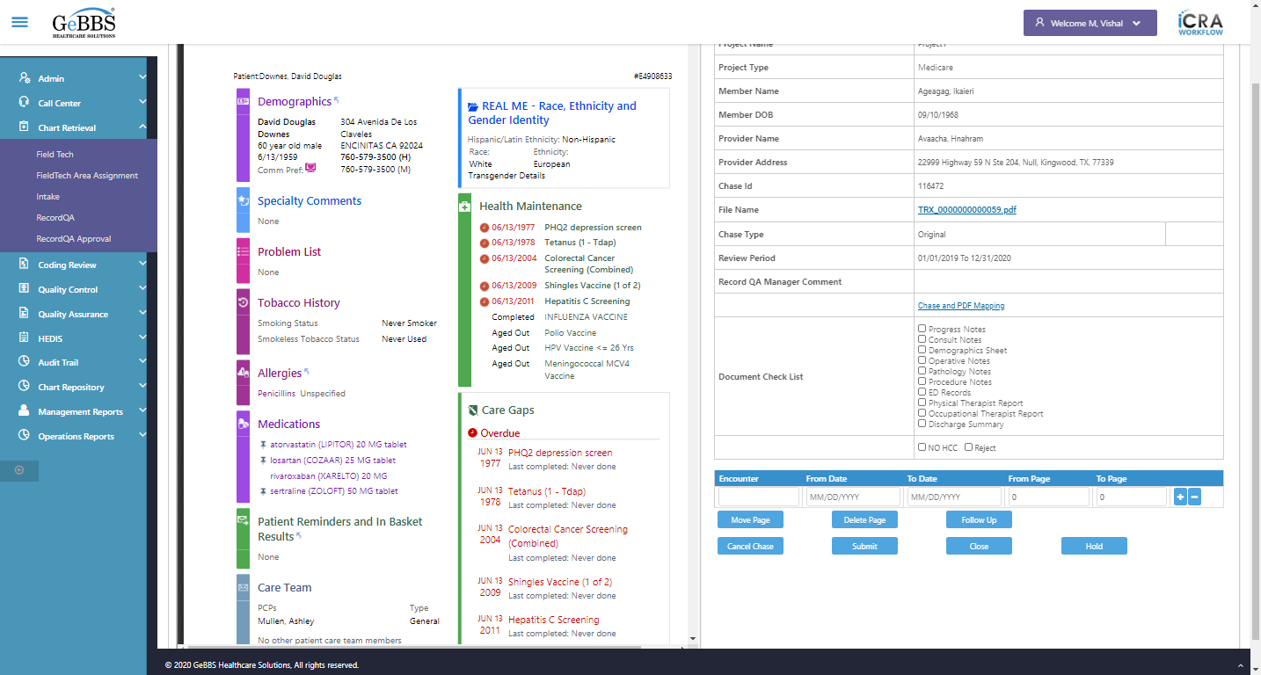  
Scrolled successfully  
click on Zoomout is clicked  
Zoom out functionality working properly   
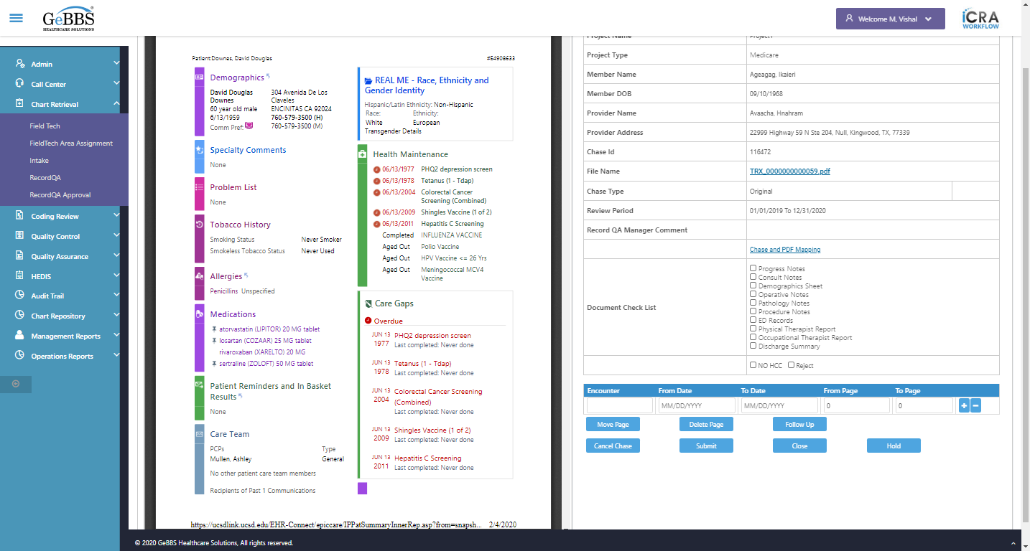  
Scrolled successfully  
Total Count of PDF Page found and switched to   
PDF Tools is clicked  
RotateClockwise is clicked  
Rotate Counter functionality working properly   
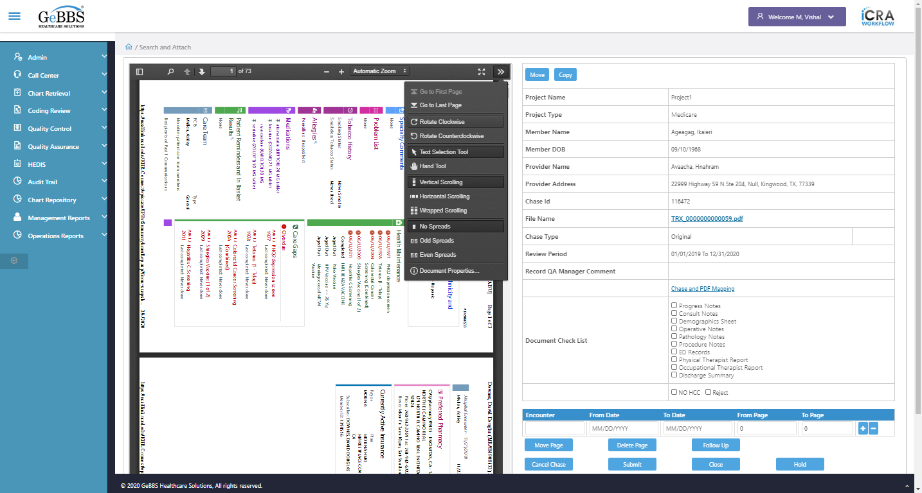  
RotateCounterClockwise is clicked  
Rotate Counter Clokwise functionality working properly   
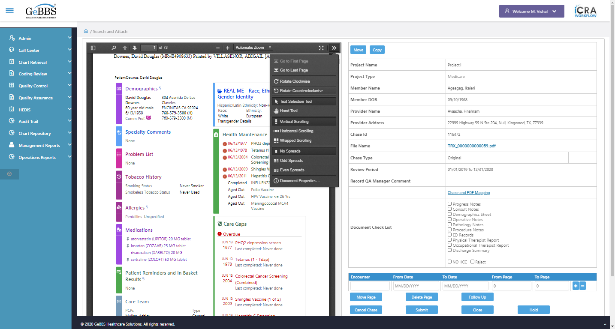  
Scrolled successfully  
Go To Last page is clicked  
Go to last page functionality working properly   
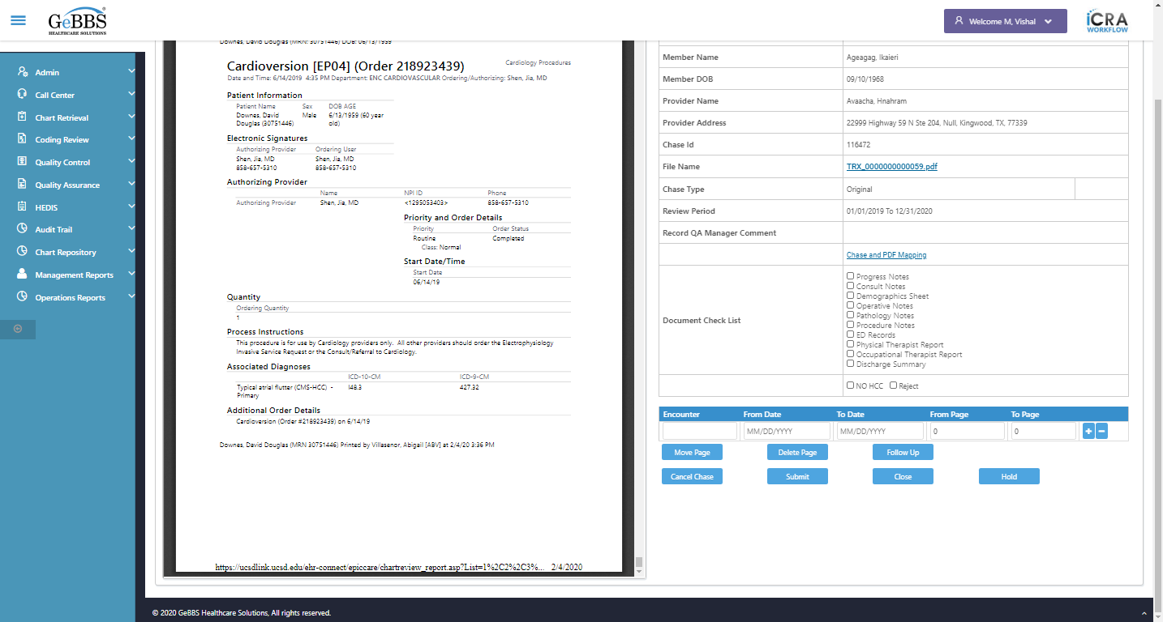  
Scrolled successfully  
Total Count of PDF Page found and switched to   
PDF Tools is clicked  
Scrolled successfully  
Go To first page is clicked  
Go to first page functionality working properly   
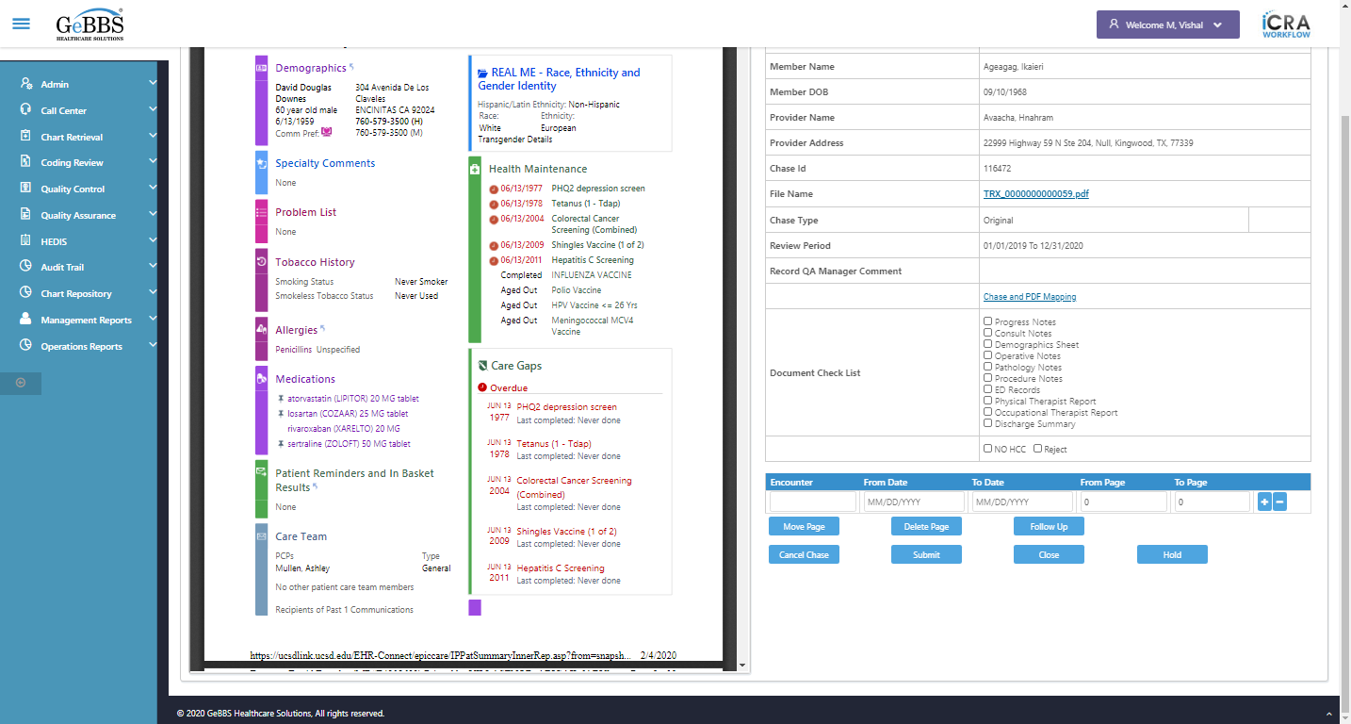  
Scrolled successfully  
Total Count of PDF Page found and switched to   
PDF Tools is clicked  
Scrolled successfully  
Horizontal_Scroll_label is clicked  
Horizontal_Scroll_label functionality working properly  
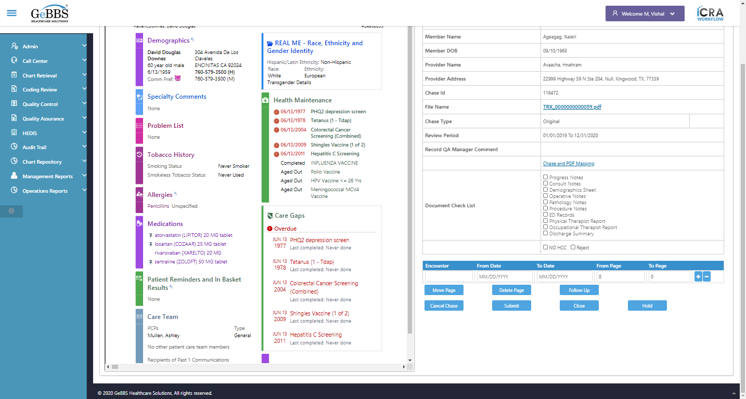  
Scrolled successfully  
Total Count of PDF Page found and switched to   
PDF Tools is clicked  
Scrolled successfully  
Vertical_Scroll_label is clicked  
Vertical_Scroll_label functionality working properly  
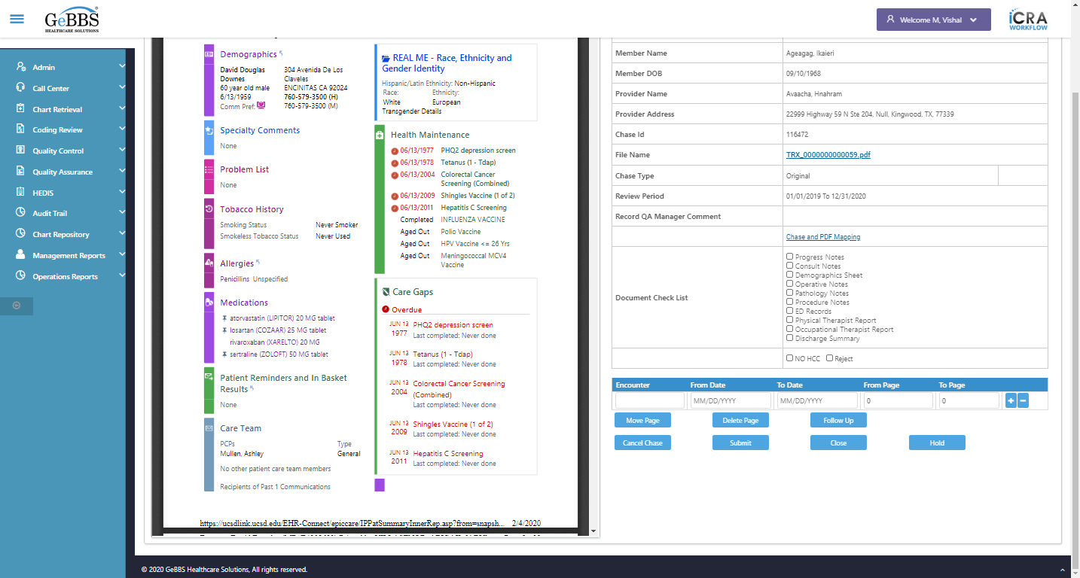  
Scrolled successfully  
Total Count of PDF Page found and switched to   
PDF Tools is clicked  
Scrolled successfully  
Spread_odd_label is clicked  
Odd Spread functionality is working  
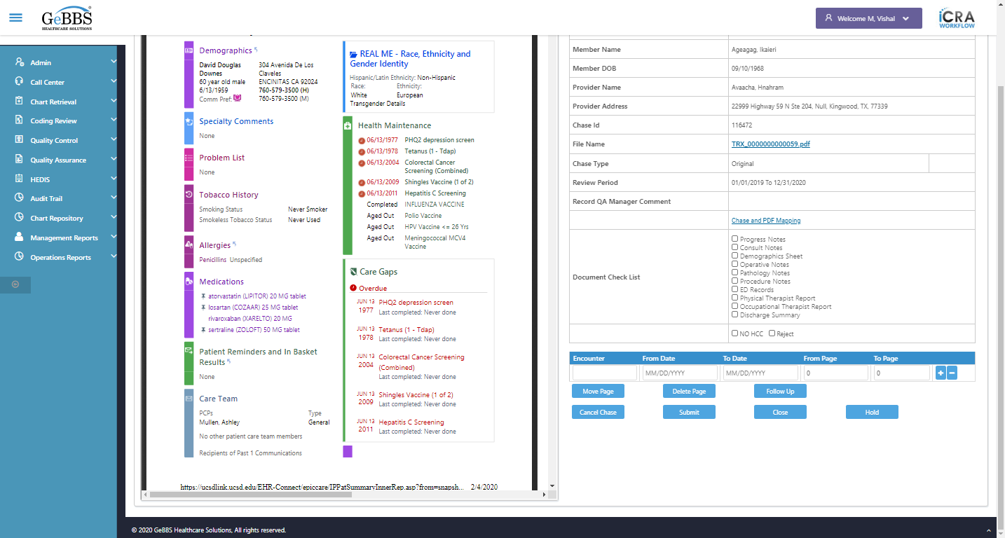  
Scrolled successfully  
Total Count of PDF Page found and switched to   
PDF Tools is clicked  
Scrolled successfully  
Spread_none_label is clicked  
No Spread functionality is working  
  
Scrolled successfully  
Total Count of PDF Page found and switched to   
PDF Tools is clicked  
Scrolled successfully  
Spread_odd_label is clicked  
Even Spread functionality is working  
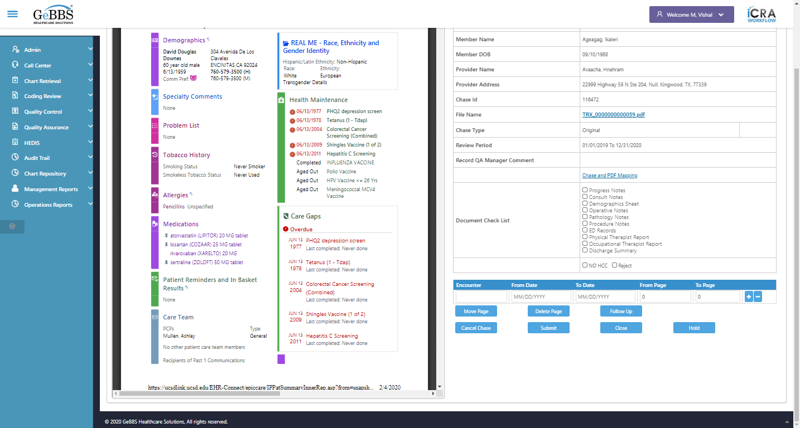  
Scrolled successfully  
Total Count of PDF Page found and switched to   
PDF Tools is clicked  
Scrolled successfully  
Document_properties_label is clicked  
close is clicked  
Doc Properties diaglog is opened   
  
Scrolled successfully  
Total Count of PDF Page found and switched to   
Toolbar Button is clicked  
Thumbnail View is displayed  
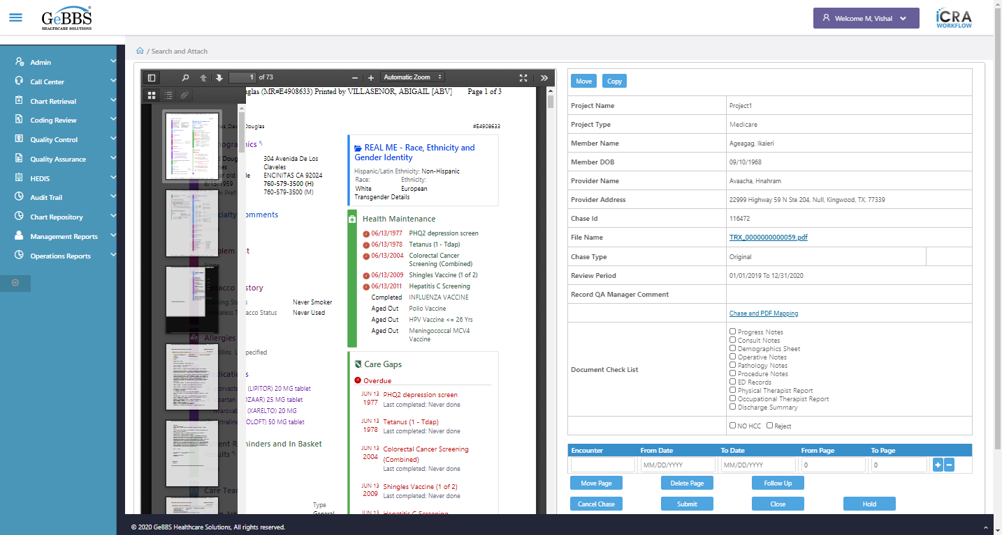  
Thumbnail View is display   
  
2nd Page from thumbnail is clicked  
Text of the element :   
Attribute for value is : 2  
User can moved to selected page from Thumbnail Section   
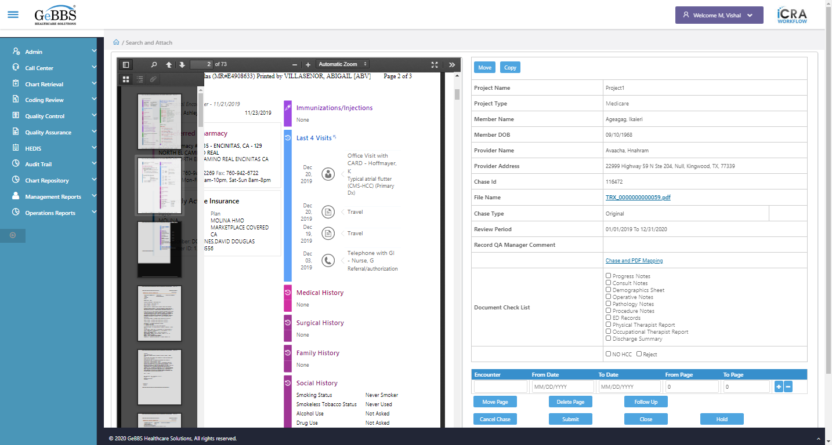  
Toolbar Button is clicked  
PDF Tools is clicked  
  
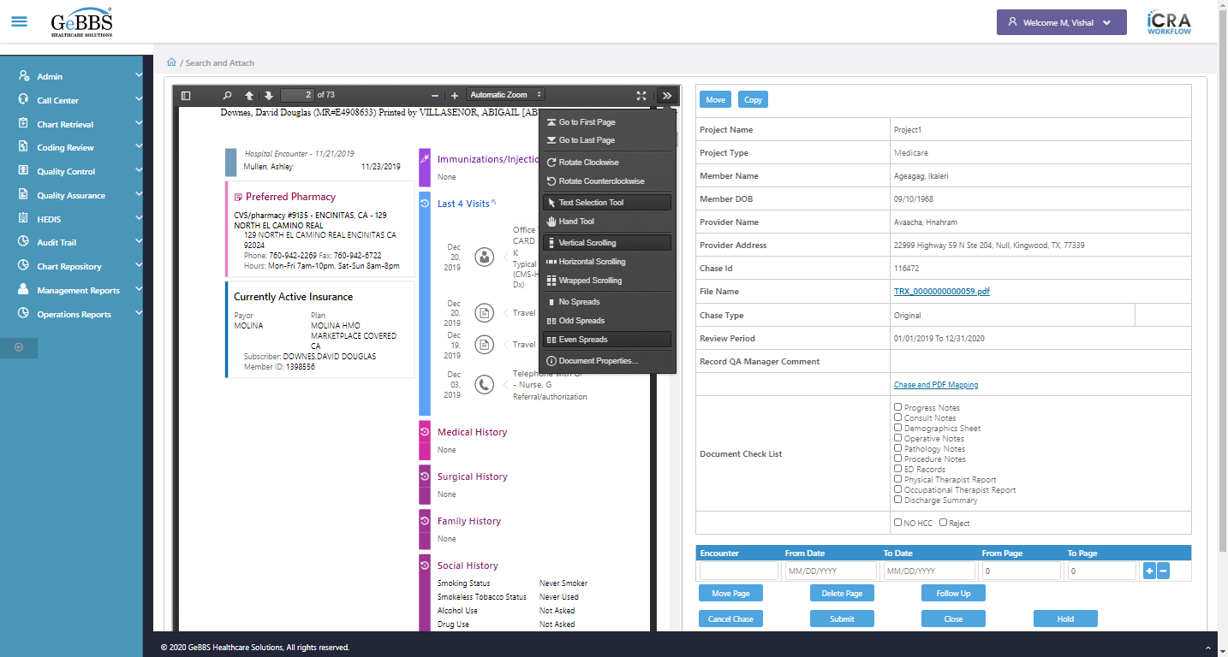  
Presentation mode functionality not working properly   
 **03/11/2020 15:14:43**